Images

Come check out our course with Google's Sam Dutton on Responsive Images by clicking [**here**](https://www.udacity.com/course/ud882)!

You can also more information about responsive images in Google's developer resources by clicking [**here**](https://developers.google.com/web/fundamentals/media/images/).

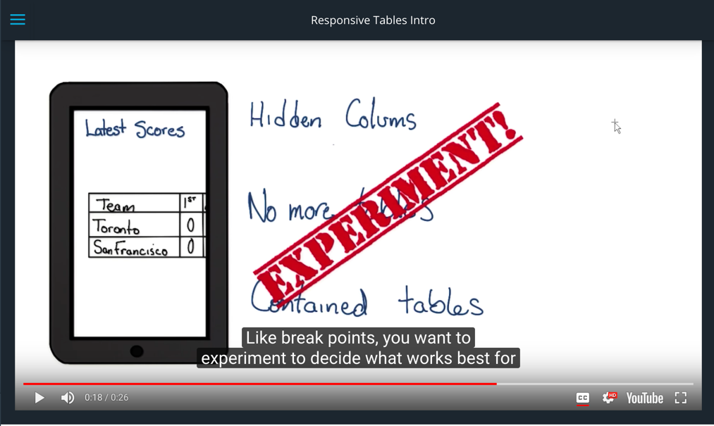

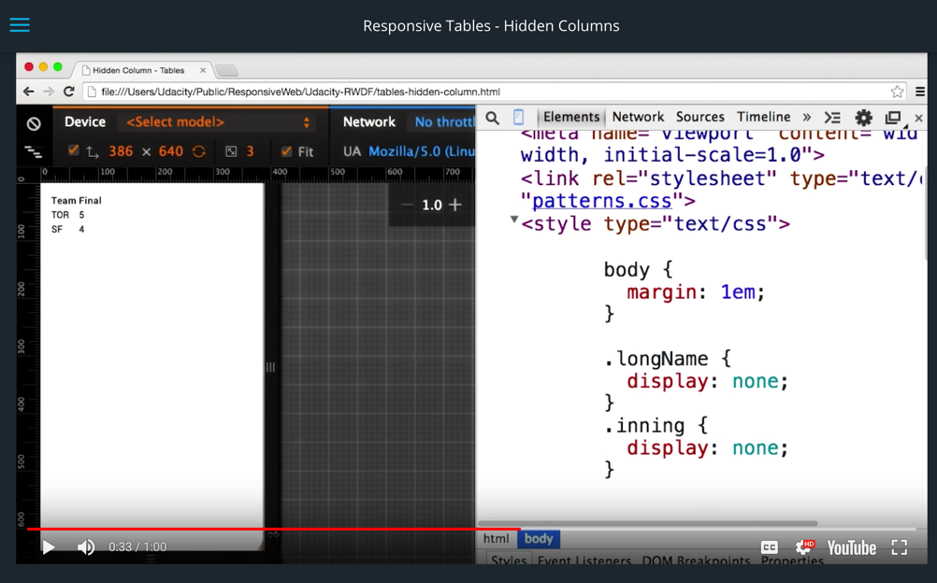

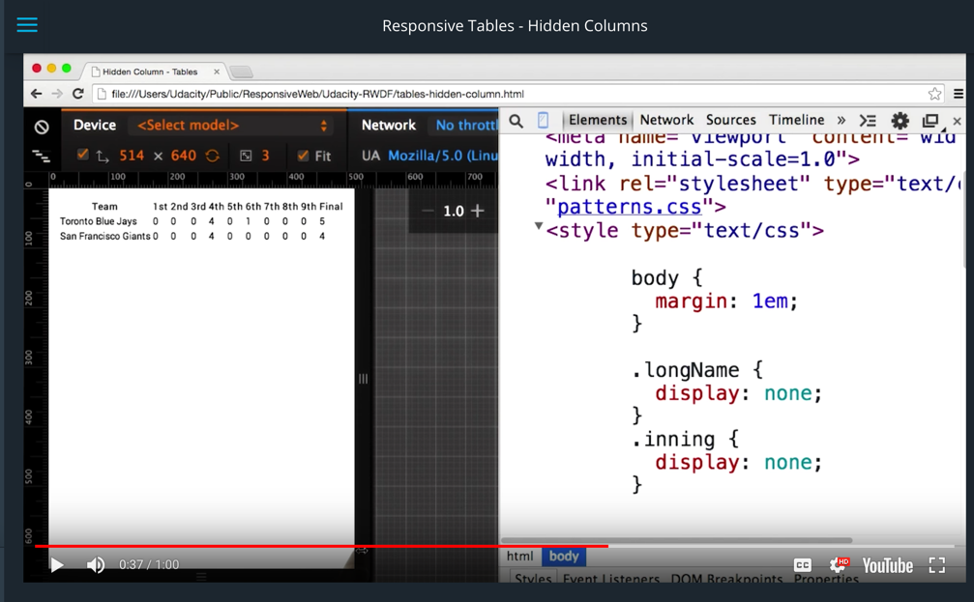

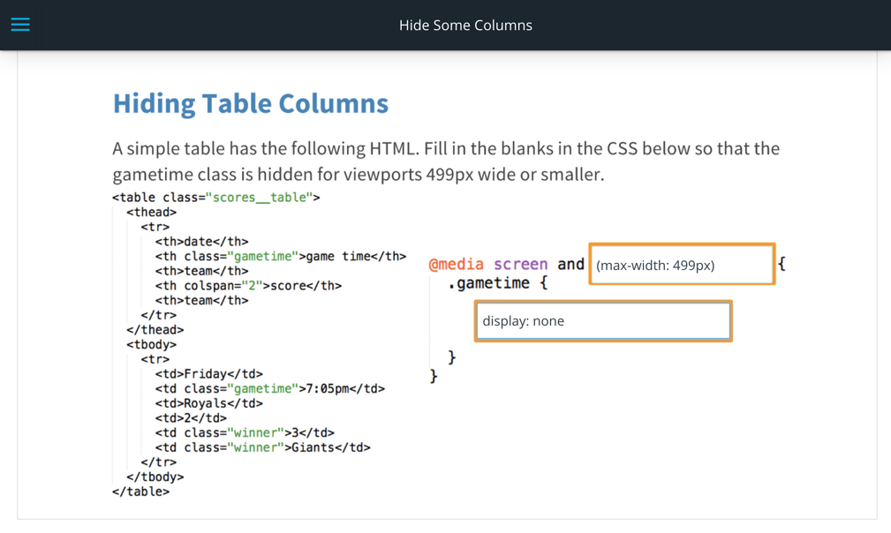

Remember, your answer needs to be valid CSS!

Hint: if you don't want an element to **display**, what property can you set with CSS? [**This article comparing display:none and visibility: hidden**](http://webdesign.about.com/od/css/f/blfaqhidden.htm) might be helpful.

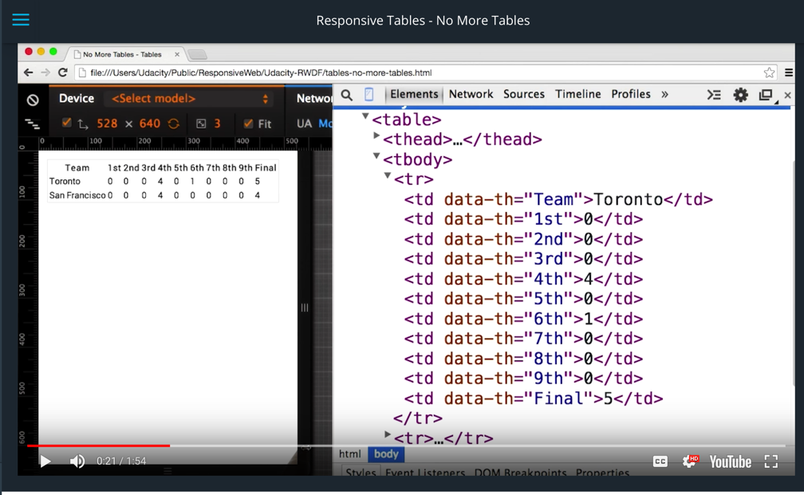

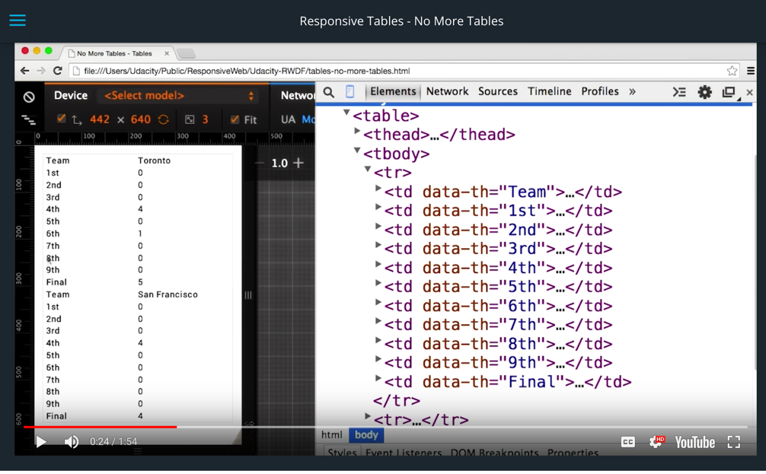

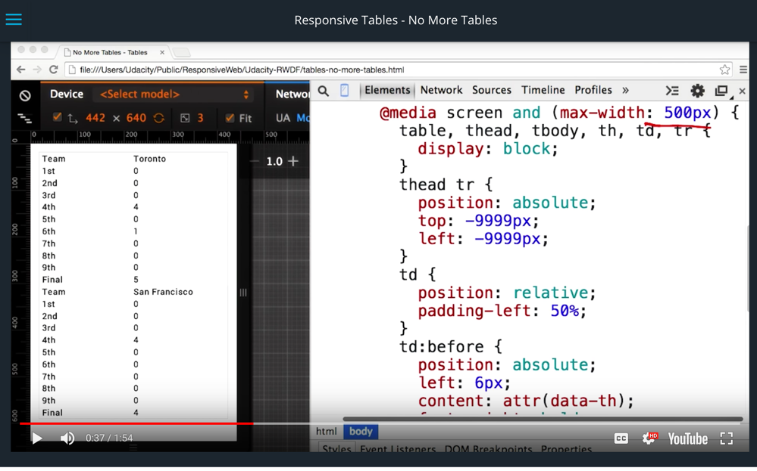

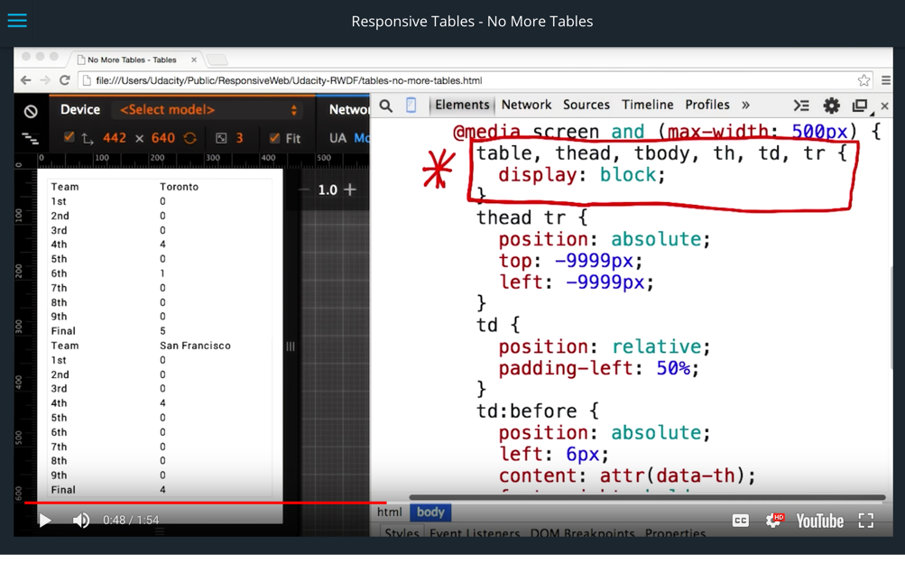

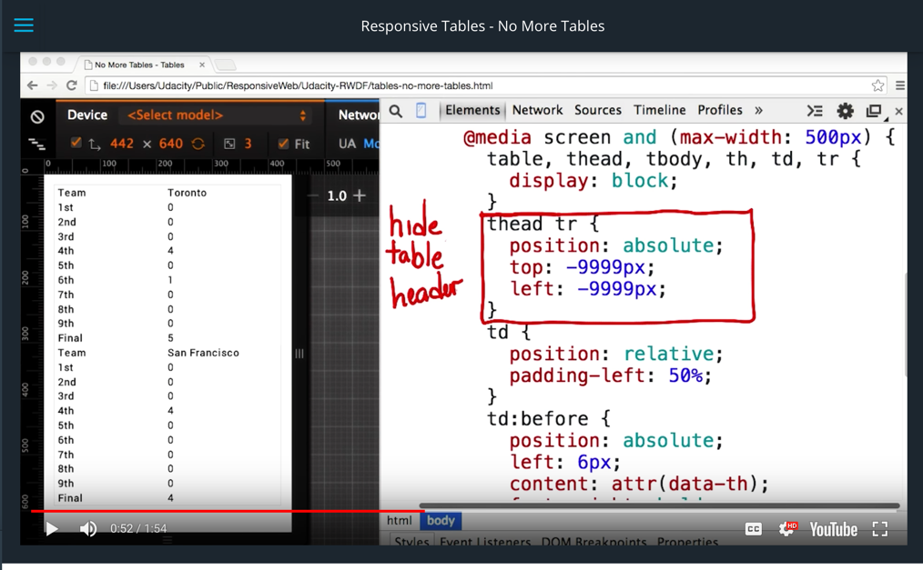

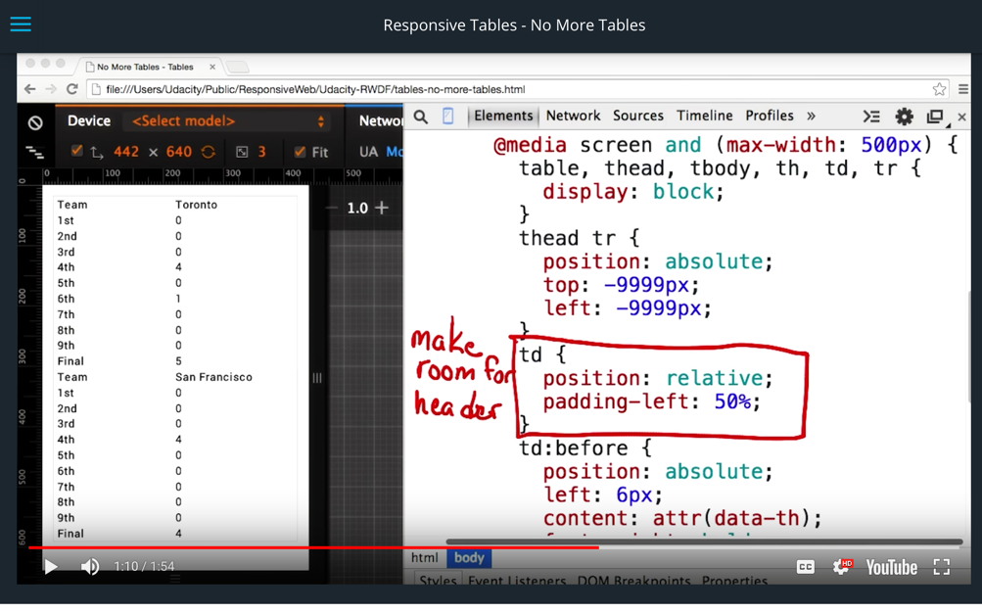

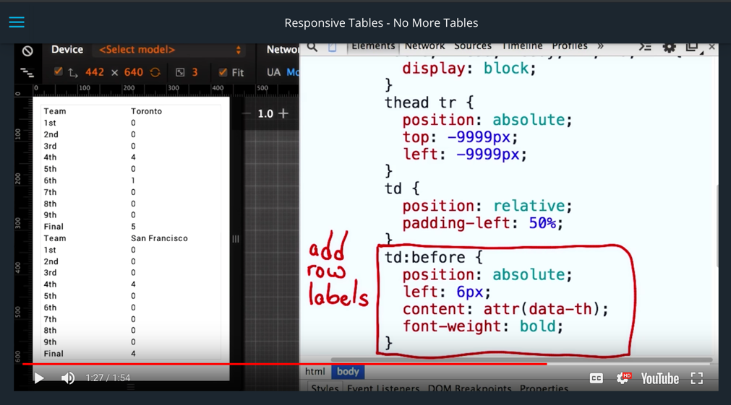

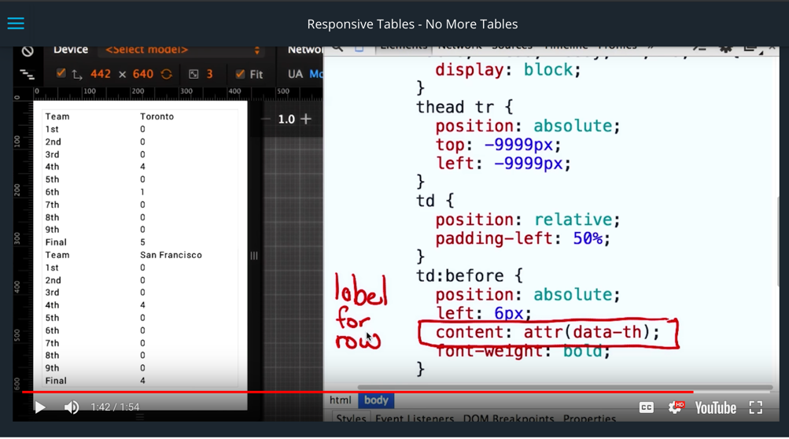



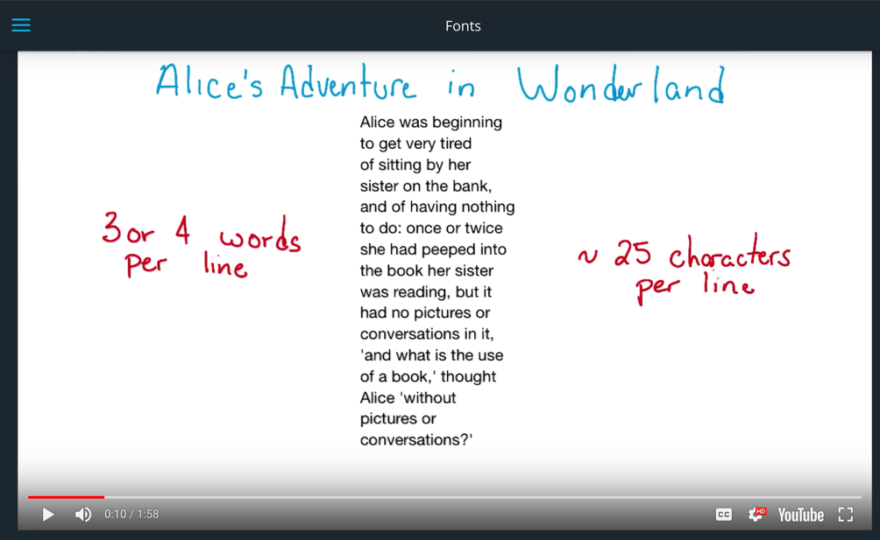

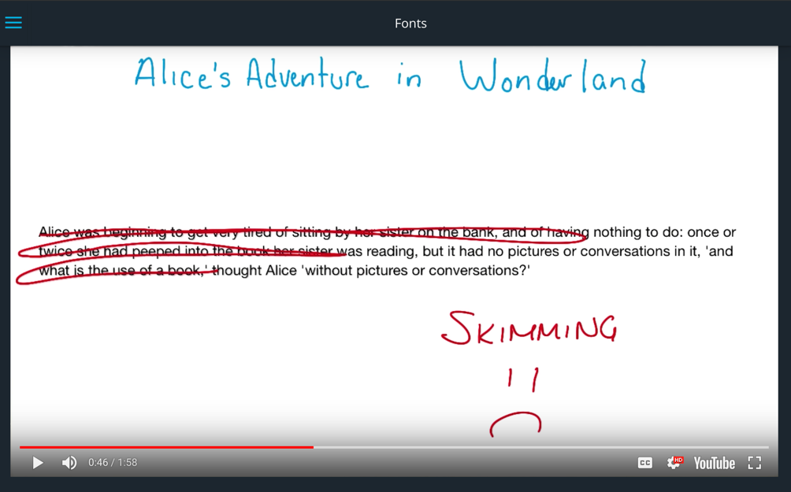

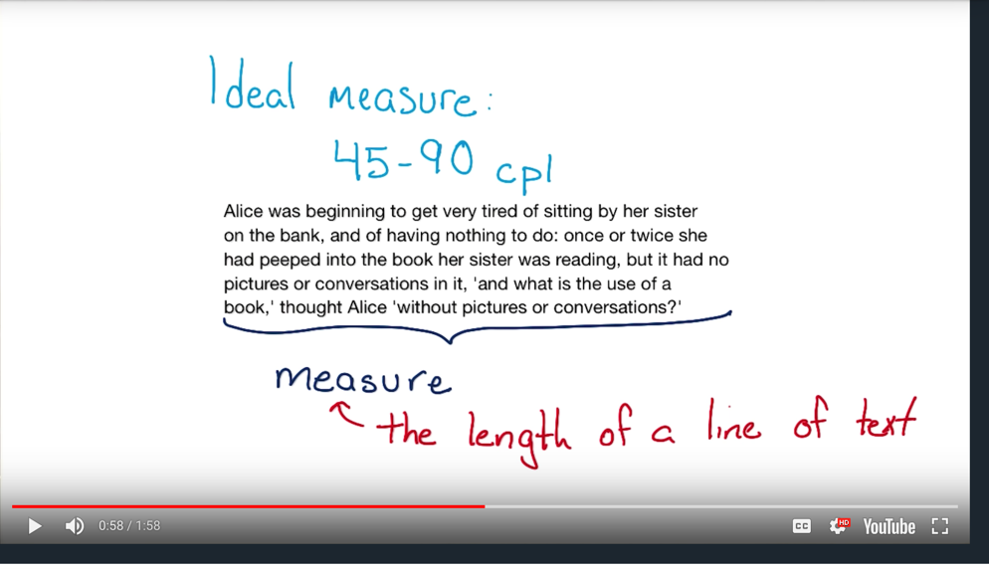

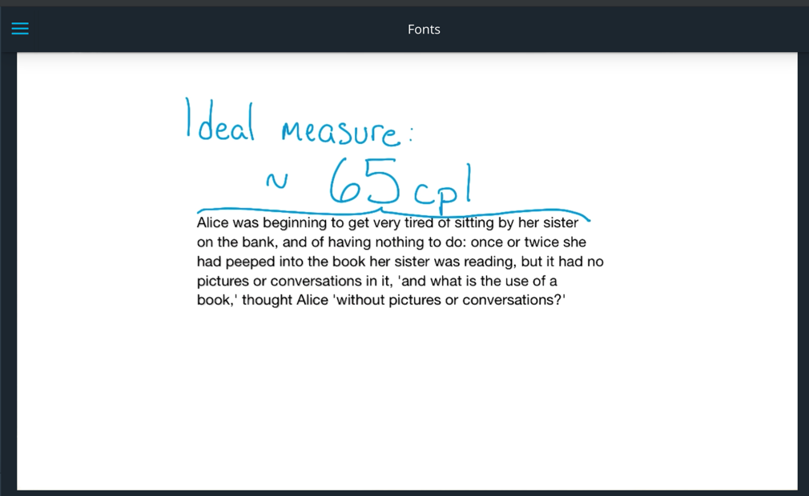

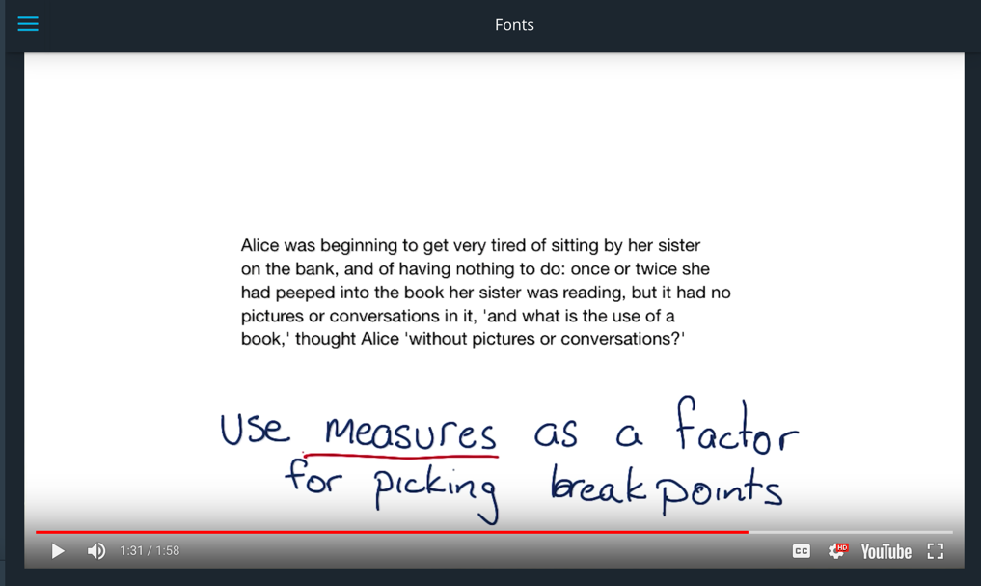

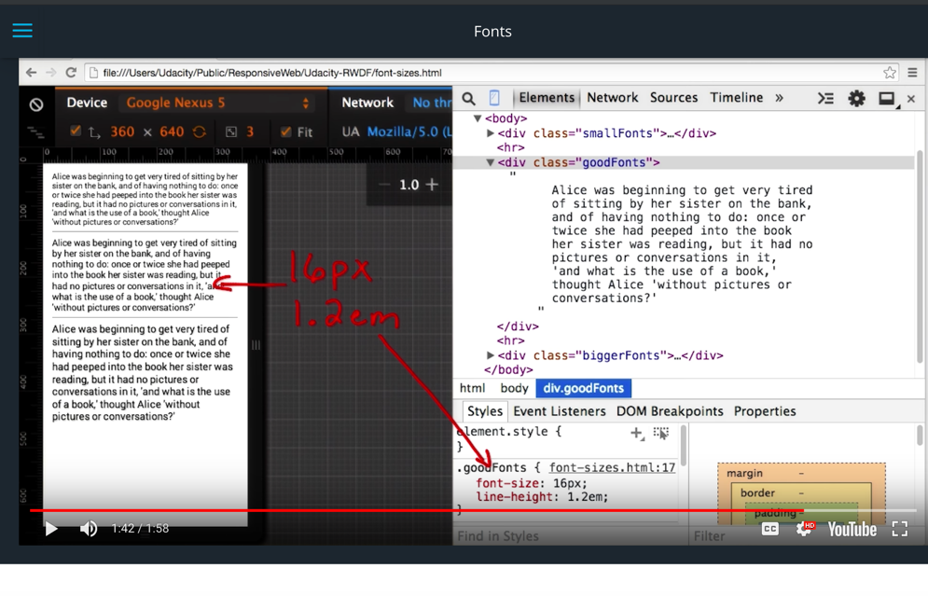

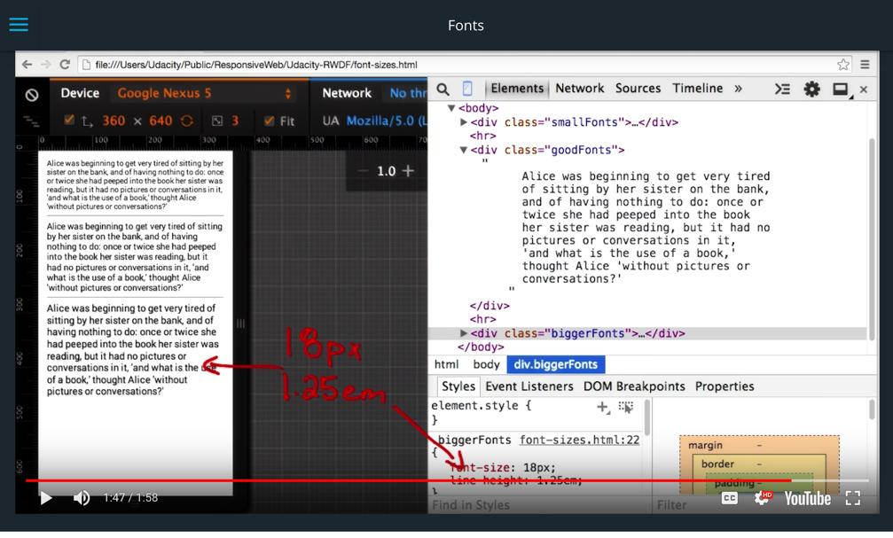

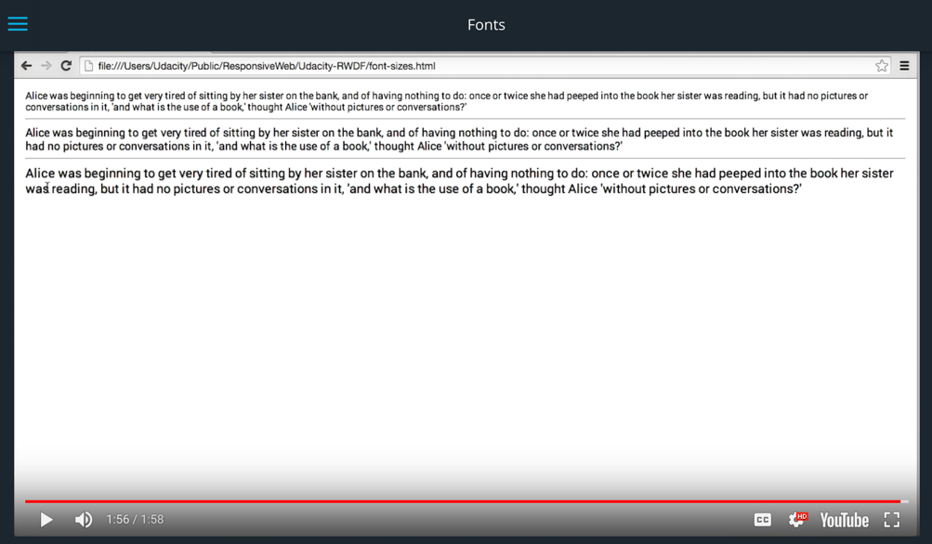

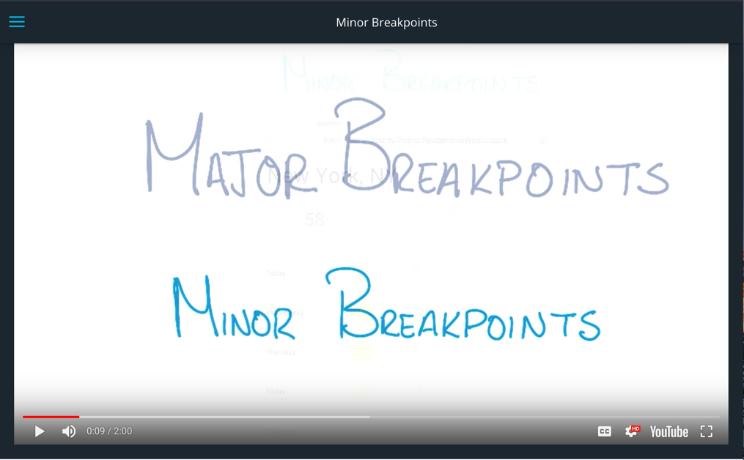

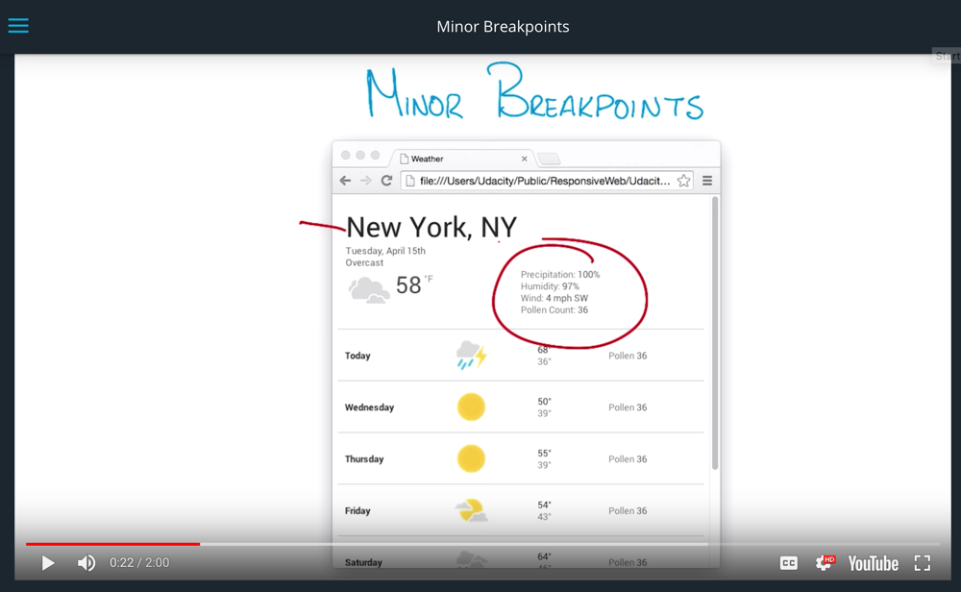

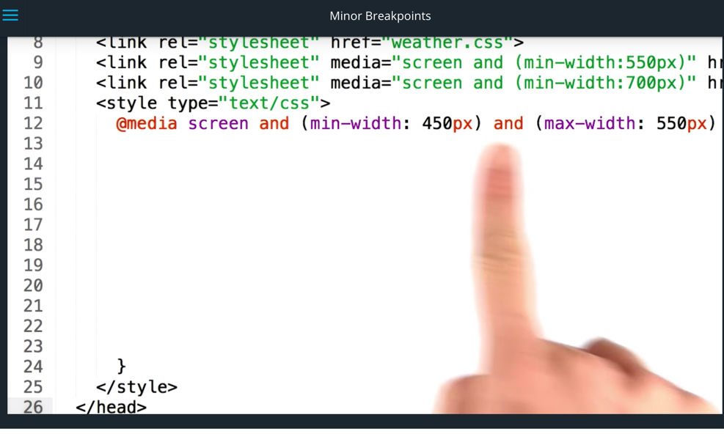

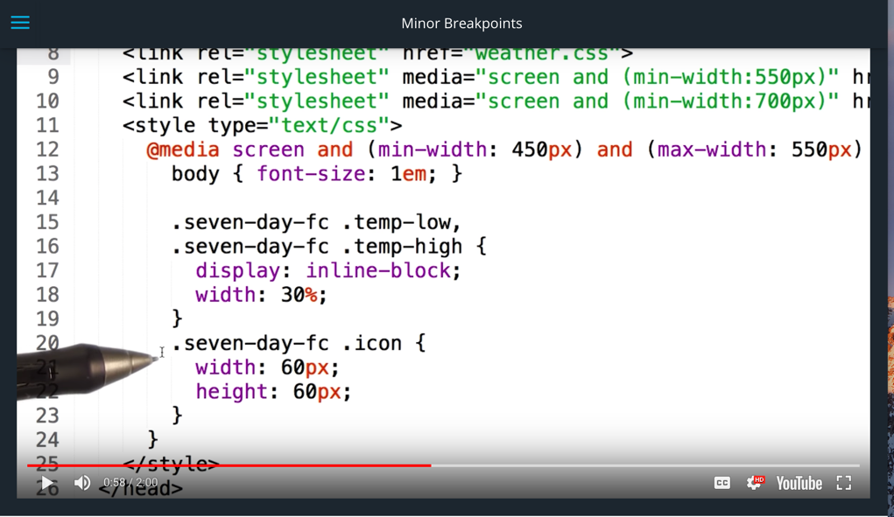



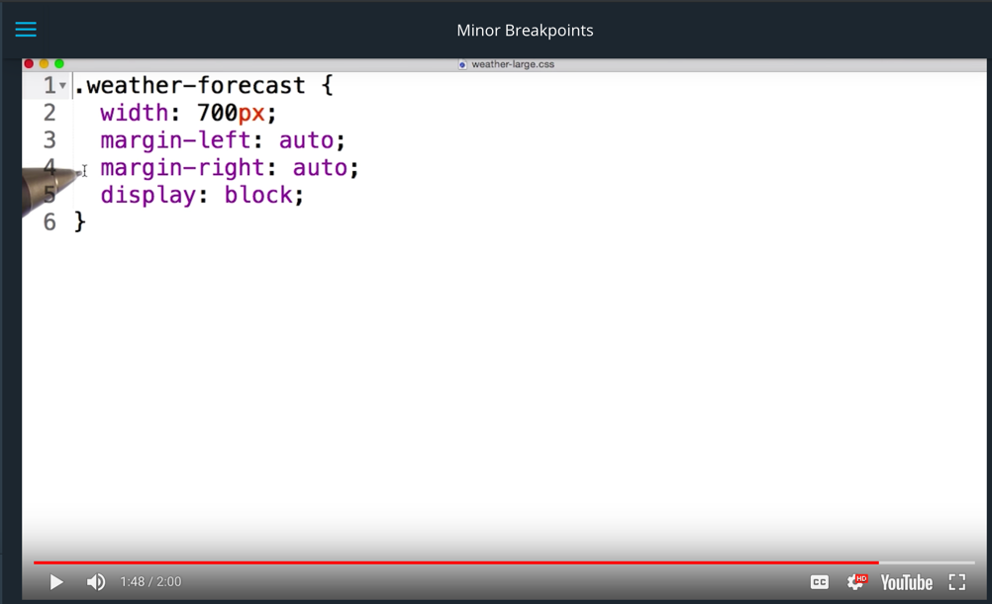

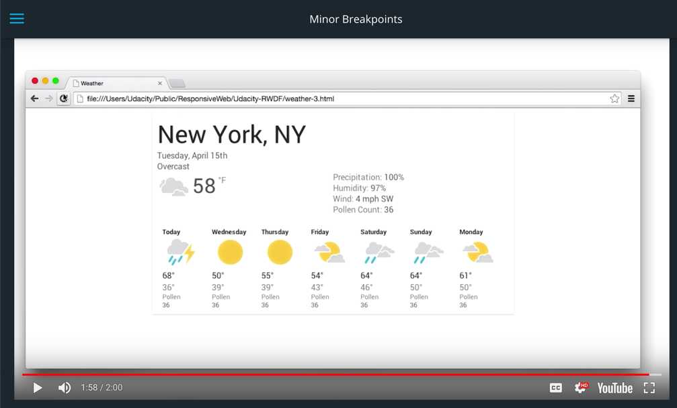

[**Responsive Images Course**](https://www.udacity.com/course/responsive-images--ud882)

[**More on responsive images with Google's Web Fundamentals**](https://developers.google.com/web/fundamentals/media/images/)

You can find the link to the RWDF_L5_start.zip file with all the files you need for the project [**here**](https://www.udacity.com/api/nodes/3565149237/supplemental_media/rwdf-l5-startzip/download?_ga=1.28732667.672083044.1467344711).

How did the ellipsis happen? [**Here's a trick**](http://css-tricks.com/snippets/css/truncate-string-with-ellipsis/) for adding an ellipsis to a single line, and here's a trick for [**adding an ellipsis when you have multiple lines**](http://hackingui.com/front-end/a-pure-css-solution-for-multiline-text-truncation/). These can be tricky. It took a bit of trial-and-error on my part before I was happy with the result.

You can find a link to the RWDF_L5_Solution.zip file with our solution to this part of the project [**here**](https://www.udacity.com/api/nodes/3484399460/supplemental_media/rwdf-l5-solutionzip/download?_ga=1.226995674.672083044.1467344711).